***Directions: Create an advertisement for the potion that Dr. Jekyll invents in the text.***

***Requirement: Use text and images to convey the literal and figurative effects of the potion.***

**You must:**

* Appeal to senses (imagery)
* Create at least one symbol (text and/or image)
* Address the thematic irony behind taking the potion
* Identify and use at least one quote, cited from the text to support your advertising claim.
* Include a cost and a warning label

**Rubric Criterion:**

50-45 Exceeds Expectations

40-44 Meets Expectations

35-39 Approaches Expectations

30-34 Deficient

29< Fail

**Time Period elements: (Consider the influence of Poe, Shelley, and Stevenson)**

* Romantic Influence
  + Imagination over reason
* Victorian Influence
  + The “gilded” effect

**Pride in Presentation**

* No pencil visible
* Can see advertisement from across the room
* Artistic effort is demonstrated
* Purposeful visual syntax is used

**Rationale**

Complete a one paragraph rationale (minimum 150 words) explaining your poster. Be able to identify clearly WHAT you have done and WHY you feel it was effective – both as an advertisement AND as a reflection of the text. Submit your typed rationale to tii.com by due date.

Dr. Jekyll and Mr. Hyde: Potion Advertisement

***Directions: Create an advertisement for the potion that Dr. Jekyll invents in the text.***

***Requirement: Use text and images to convey the literal and figurative effects of the potion.***

**You must:**

* Appeal to senses (imagery)
* Create at least one symbol (text and/or image)
* Address the thematic irony behind taking the potion
* Identify and use at least one quote, cited from the text to support your advertising claim.
* Include a cost and a warning label

**Time Period elements: (Consider the influence of Poe, Shelley, and Stevenson)**

**Rubric Criterion:**

50-45 Exceeds Expectations

40-44 Meets Expectations

35-39 Approaches Expectations

30-34 Deficient

29< Fail

* Romantic Influence
  + Imagination over reason
* Victorian Influence
  + The “gilded” effect

**Pride in Presentation**

* No pencil visible
* Can see advertisement from across the room
* Artistic effort is demonstrated
* Purposeful visual syntax is used

**Rationale**

Complete a one paragraph rationale (minimum 150 words) explaining your poster. Be able to identify clearly WHAT you have done and WHY you feel it was effective – both as an advertisement AND as a reflection of the text. Submit your typed rationale to tii.com by due date.

Student Example:

Rationale: Dr. Jekyll and Mr. Hyde tells a story particular to the Victorian Age. This was a time of facades, and Dr. Jekyll was the perfect example of someone who wanted to be someone on the outside, but had dark desires on the inside he could not act on. In my ad, I used symbols, like the color green for envy and the lightning bolt to represent a split. The handcuff demonstrates that you could be set free from your restrained life! I offer all of this for the low price of 50 Pounds! This is expensive for the time period, because it would have appealed to the upper class. They were the people who had the most to lose from indulging in their dark side. My quote serves as customer testimony. I have bolded words that would appeal to someone considering my potion. Overall, this ad appeals to people who are interested in creating a guilt free duality.

WC: 158

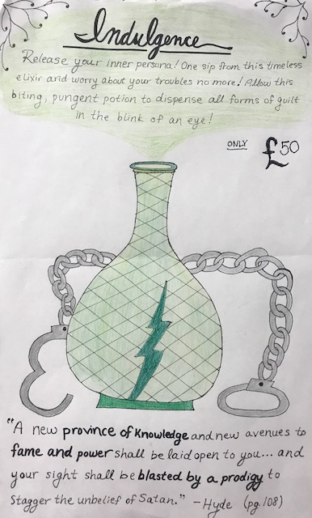

Rationale: Dr. Jekyll and Mr. Hyde tells a story particular to the Victorian Age. This was a time of facades, and Dr. Jekyll was the perfect example of someone who wanted to be someone on the outside, but had dark desires on the inside he could not act on. In my ad, I used symbols, like the color green for envy and the lightning bolt to represent a split. The handcuff demonstrates that you could be set free from your restrained life! I offer all of this for the low price of 50 Pounds! This is expensive for the time period, because it would have appealed to the upper class. They were the people who had the most to lose from indulging in their dark side. My quote serves as customer testimony. I have bolded words that would appeal to someone considering my potion. Overall, this ad appeals to people who are interested in creating a guilt free duality.

WC: 158

